 | Down and Connor  Catholic Schools' Support Service  120 Cliftonville Road  Belfast BT14 6LA  T: 028 9049 1886  E: dctrusteeservice@downandconnor.org | 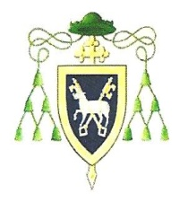

18 January 2021

Miss Mary McHenry, Principal
St Louise’s Comprehensive College
468 Falls Road
BELFAST BT12 6EN

Dear Miss McHenry

On behalf of the Down and Connor Catholic Schools’ Support Service, I thank you for submitting a nomination for your school to be considered for the Spirit of Catholic Education Award 2021. We are delighted with the number of nominations received. The adjudication panel was most impressed by the examples of “best practice” and with how the Self-Reflection Framework document is assisting schools in developing the ethos and values of Catholic education.

It gives me great pleasure to inform you that St Louise’s Comprehensive College has been awarded:

The Spirit of Catholic Education Award 2021

Distinction

This is in recognition of your school’s outstanding commitment to and engagement with promoting and developing Catholic ethos and values as outlined in the quality indicators detailed in the Down and Connor Catholic Ethos: A Framework for Self-Reflection.

In particular, St Louise’s Comprehensive College has received this award because of its outstanding work in the area of Religious Education. The school has consciously reflected on its Vincentian vision and mission and engaged most energetically in revisiting and enhancing religious education throughout the school, and especially at Key Stage 3. Its revitalised thematic RE programme which includes excellent opportunities for faith formation, prayer, liturgical experiences, retreats and reflections and an enhanced appreciation and application of Vincentian values is a wonderful example of a school that places religious education at the centre of school life.

To acknowledge this wonderful achievement, the Down and Connor Catholic Schools’ Support Service are planning to present the award to your school when the current health and safety regulations allow. This will be organised in line with all necessary health and safety regulations around Covid-19. Your link member of the Down and Connor Catholic Schools’ Support Service Team, Dr Aidan Donaldson will be in contact with you to discuss any future arrangements for the presentation of this prestigious award.

Congratulations to everyone in St Louise’s College. Please extend my very good wishes to the entire school community on this wonderful achievement.

May God bless you and everyone in your school community in the year ahead.

With warmest regards

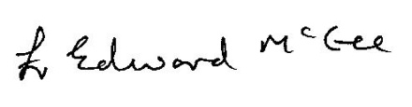

Fr Edward McGee
Director of the Down and Connor Catholic Schools’ Support Service

