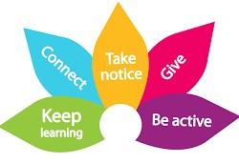

**Year 10 Mid-Term Break: 15th – 19th Feb**

Dear parents. We hope you have found some time to relax in the past week. We would like to thank you for your continued and ongoing support of your daughter/son as they prepare to start a new half term. These weeks will bring fresh challenges and opportunities. In the coming weeks we will be focusing on subject choices and options for KS4. Rest assured that your child will be given opportunities to learn about and explore all the possibilities open to them. We will be kicking off our programme with a Think Big workshop on the 8th March.

**Hello Year 10!**

We hope you have had a relaxing break and that you have caught up on any work you had previously missed. If you had not been engaging online, this is the time to refresh, reset and start again on the 22nd February; it is never too late to start working and learning! Our next few weeks will be very important as we begin to pave the way forward for next year when you are mature Year 11 students! We look forward to ‘seeing’ you in class on Monday at 9am in registration.

|  |  |
| --- | --- |
|  | **Monday 22nd February at 8.55am** |

T**ake good care parents and students – enjoy the rest of your break and we will ‘see’ you online on the 22nd February!**

