Health and Safety
Covid 19 Safety rules
- Adhere strictly to the latest Covid 19 restrictions at all times.
- Carry out the distances with a member of your household bubble.
- Remain at least 2m distance from members of the public.
- Stay within a 10mile radius from your home.
- If you have to leave your home for exercise limit this to once per day.
- You can exercise in a public outdoor place with the people you live with.
- Public outdoor places include:
  - parks, beaches, countryside accessible to the public, forests
  - public and botanical gardens (whether or not you pay to enter them).
  - the grounds of a heritage site.
  - public playgrounds.
- Playgrounds are primarily open for use by children who do not have access to private outdoor space, like their own garden.
- Although you can take your children to a playground for exercise, you must not socialise with other people while there.
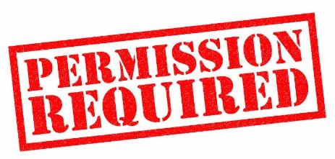
Being Safe on the roads
- Plan your route in advance and share it with your parents.
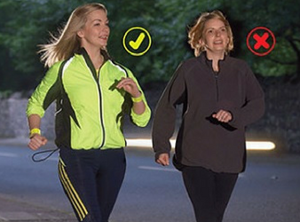
- Get your parents’ permission, or better still get them or a member of your household bubble to accompany you.
- Be visible at all times. Wear bright clothing during the day, and wear reflective materials or use a flashlight in the evening.

- Wear appropriate safety gear e.g. bicycle helmet.

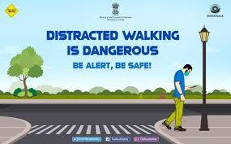
- Walk on footpaths whenever they are available. If there is no sidewalk, walk facing traffic and as far from traffic as possible.

- Keep alert at all times; do not be distracted by electronic devices that take your eyes (and ears) off the road.
- Whenever possible, cross streets at crosswalks or intersections, where drivers expect pedestrians.
- Watch for cars entering or exiting driveways

