[](https://www.bing.com/images/search?view=detailV2&ccid=tB2yI1f9&id=E457B72B698D2EB3E01A3E2A9583E0B5FFC82AEB&thid=OIP.tB2yI1f9S5bUyfc58Xx3CQHaHp&mediaurl=https://i1.wp.com/poklib.org/wp-content/uploads/2016/03/books-ribbon.jpg&exph=3246&expw=3143&q=chirstmas+clipart+books&simid=607991958826975987&ck=775784539725F08CBE073F984FE80FFE&selectedIndex=4&adlt=strict&FORM=IRPRST)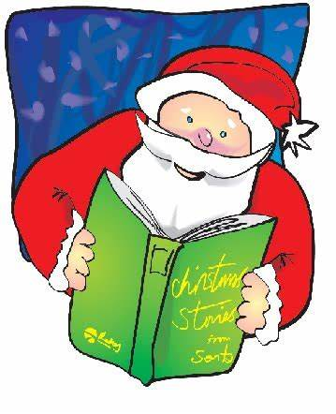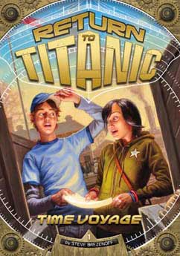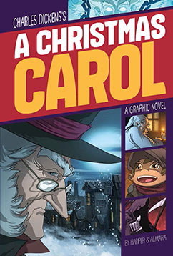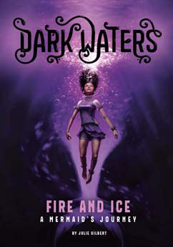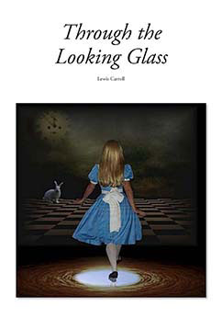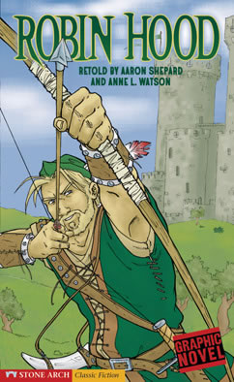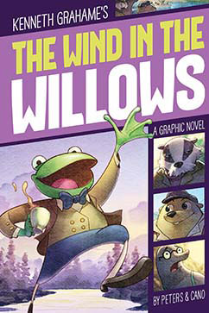

**MyON Christmas**

**Reading List**