BBC Creative Writing Competition
WIN!
WIN!

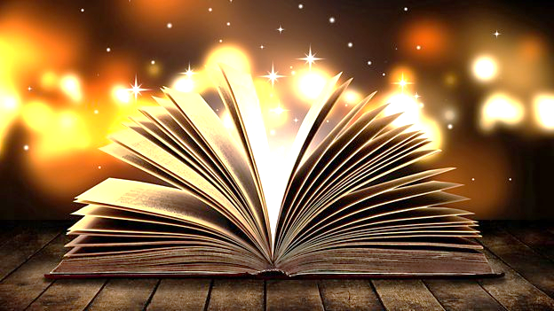

Do you want your story to become an animated film?

Get Involved in BBC Northern Ireland’s Two Minute Tales
https://www.bbc.co.uk/programmes/articles/5lTDWfmhGQR9Tlf93LkgMzv/send-in-your-two-minute-tale
Closing date: Friday 13th November 2020

