Queen’s University Belfast
School of Social Sciences, Education and Social Work
To: Parents/Guardians of Years 12 and 13 pupils
Is your son/daughter thinking of studying social sciences at university?
Queen’s University Belfast is running an online Social Sciences Summer School in August, where students can learn more about important and interesting topics such as families, religion, crime and deviance, social inequality, ethnic diversity, politics and more!
Students will have the opportunity to interact with staff and current students to get a taste of studying social sciences at university. The Summer School has run for several year now. It is always popular and has received great feedback from students. This year with the Covid-19 restrictions we have decided to move the summer school online, so that this year’s students do not miss out.
The Summer School is hosted by the QUB Q-Step Centre, a teaching hub to promote the quantitative social sciences, with funding from the Nuffield Foundation. The Summer School will consist of a series of online lectures and tutorials. Students will get the chance to work together in small on-line project groups, undertaking a series of research activities. At the end each group will make a short presentation based on research they have been undertaking over the course of the summer school.
Dates
18th, 19th and 20th August.
How to Apply
Please email Ms Zoie Watterson at z.watterson@qub.ac.uk with the following information: your school, year of study, and A Level subjects.
Best wishes
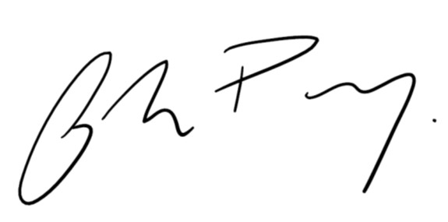

Dr Andrew Percy
Director, Q-Step Centre
School of Social Sciences, Education and Social Work
028 9097 5261

Email
Webpage
Twitter

