Befriending planet earth with Pope Francis
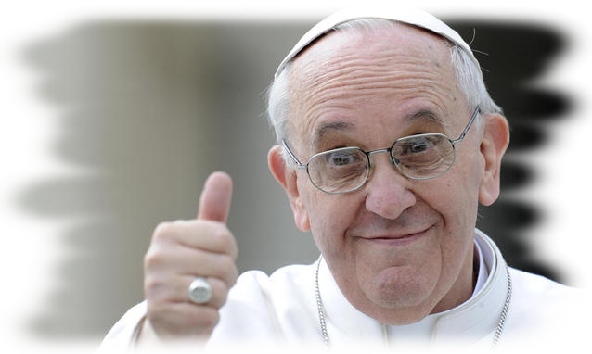
May 2020 will be remembered for Coved-19 and its impact on our community. The ‘stay at home’ rule means that we have time to notice more, to appreciate more and this includes nature and our surroundings. In Laudato Si’ Pope Francis suggests that if we really see the beauty in nature then we will do all in our power to protect it. Both the smallest plant and animal, part of our common home, are a source of ‘wonder and awe’. This time of ‘social distancing,’ difficult as it is for many, allows us some time to reflect and ‘to seek a new beginning’, and take more care of the earth.

C 1. Caring for planet earth while ‘Social Distancing’

Lord, purge our eyes to see
within the seed a tree,
within the glowing egg a bird,
Within the shroud a butterfly.
Till taught by such, we see
Beyond all creatures Thee.
Christina Rosetti.

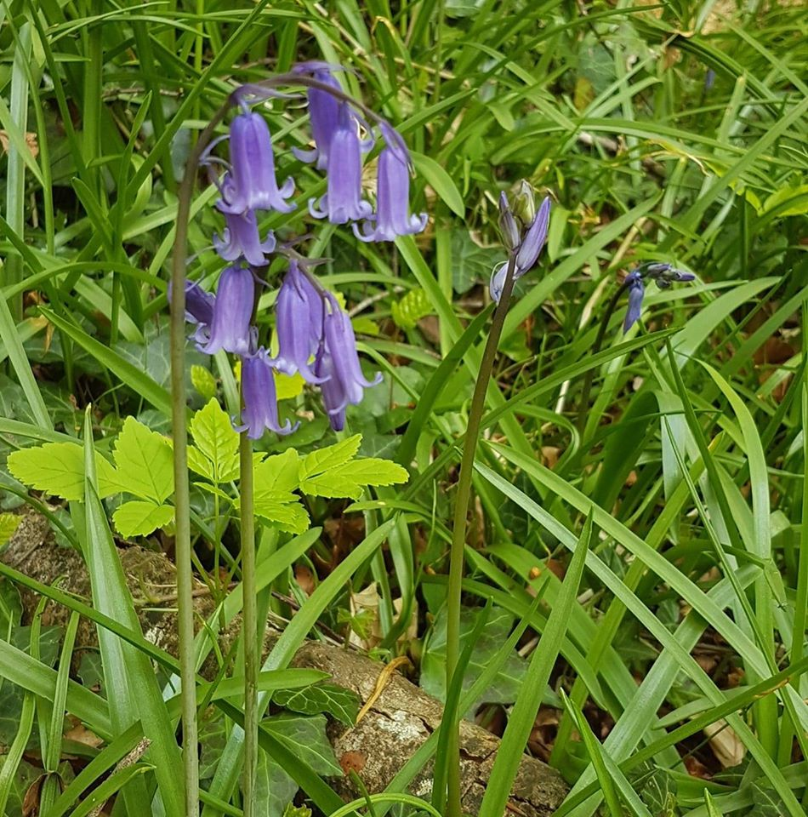

Look and See
This morning, at waterside, a sparrow flew
to a water rock and landed, by error, on the back
of an eider duck; lightly it fluttered off, amused.
The duck, too, was not provoked, but, you might say, was
laughing.

This afternoon a gull sailing over
our house was casually scratching
its stomach of white feathers with
one pink foot as it flew.
Oh Lord, how shining and festive is your gift to us, if we
only look, and see. Mary Oliver

- Study the picture and the poems. What are they saying to you about our planet?
- Notice something beautiful locally, e.g. - bird, dog/cat, tree/ flower, butterfly. Take photographs/make a video clip, include some music or birdsong for the background.
Describe how this exercise helps you appreciate God’s creation.

C 2. Social distancing is giving us time to examine our lifestyles.

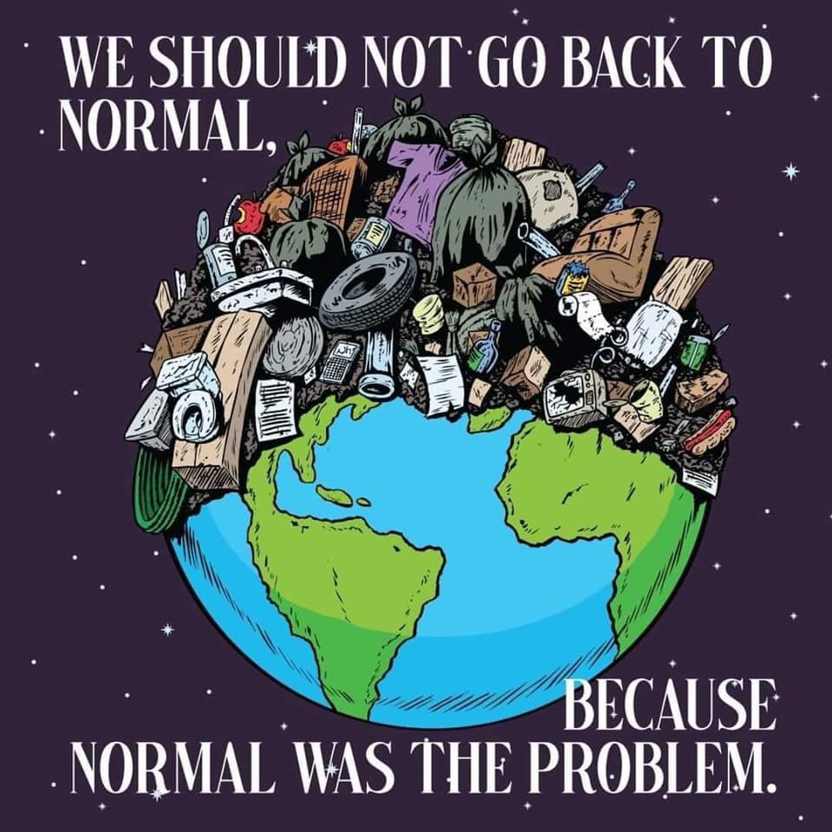
“The earth, our home, is beginning to look more and more like and immense pile of filth. … our once beautiful landscapes are now covered with rubbish.” Paragraph 21

- What is the ‘Normal’ suggested in the diagram?

- Why does it suggest that we should not go back to this ‘Normal’?

- A ‘new beginning’, a new ‘Normal’ is needed. Pick one aspect of your lifestyle e.g. use of electricity and mobile phones, clothes and cosmetics shopping. How could you change your usual habit to lessen the burden on the planet and to live a lifestyle more in balance with nature.

- Our also impact on the environment and lives of people in other countries. Research one of the following (1) dumping of waste in developing countries, (2) child labour in cheap clothing factories in developing countries. Design a poster/collage to urge your friends to live a life that takes better care of our common home and encourages responsible co-operation.

Now make the Links

Look back on your three Reflections 1. Befriend Social distancing 2. Showing care for others 3. Befriending Planet Earth Write an article for a Magazine/Newspaper on one aspect of Laudato Si’ that will stay with you after this experience of ‘Social Distancing.’ is over. The Read More section may help you with this.
Submit the article to your Head of Year by Monday May25th 2020.

