Extra reading - Laudato Si’ Week May 16-24th.

‘May our struggles and our concern for this planet never take away the joy of our hope’ Paragraph 244

- 2020 the year to stop and make us think
http://youtu.be/Nw5KQMXDiM4

- We have unfortunately allowed plastic, in particular, come into our lives, ‘almost unnoticed, like a mist seeping gently beneath a closed door.’ Laudato Si’ Paragraph 112

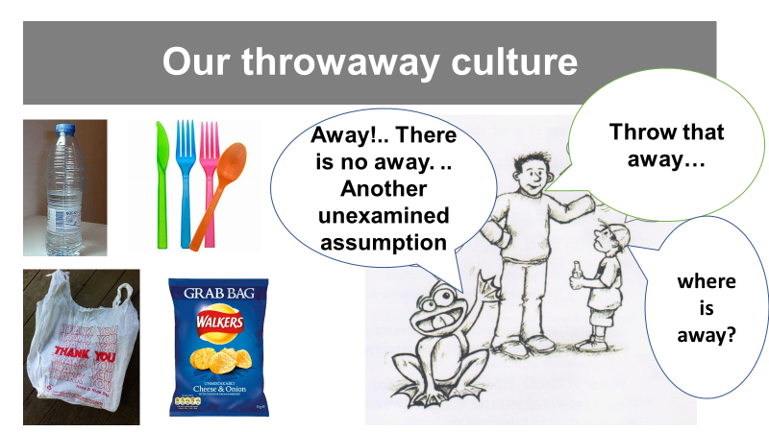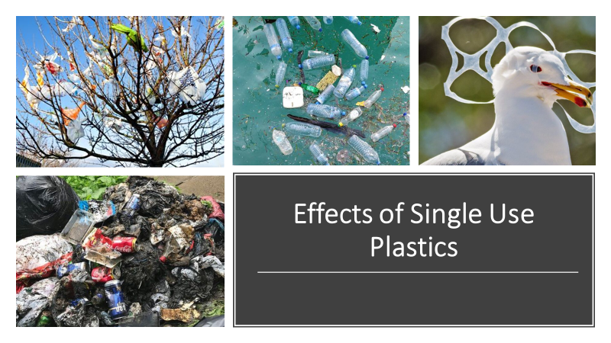
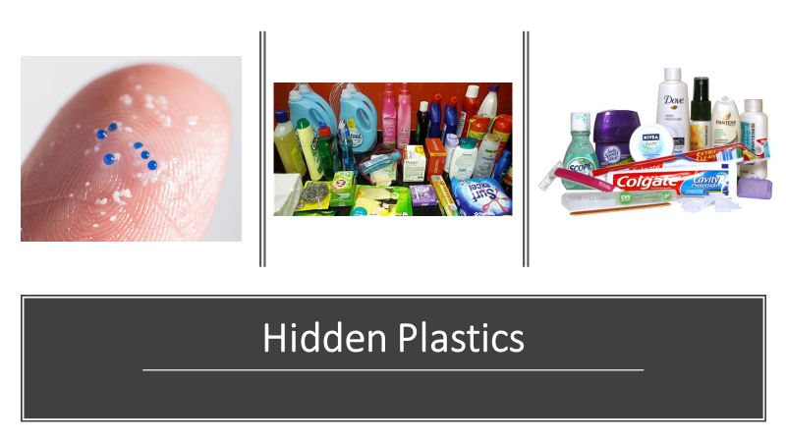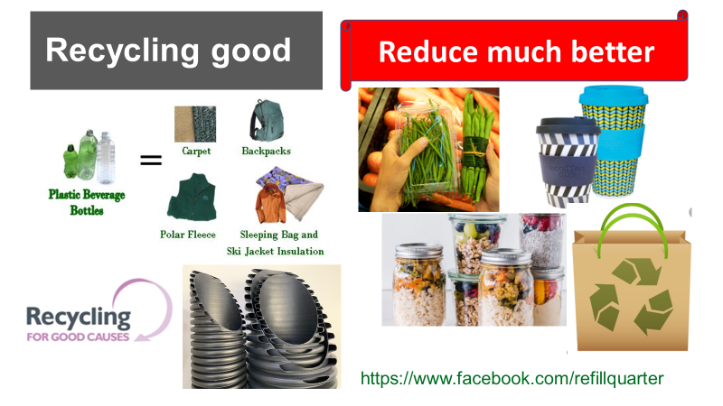

- Song ‘Who’s gonna stand up? (And save the earth)’ Neil Young

6setlang%3den-GB%26plvar%3d0%26PC%3dACTS&view=detail&mmscn=vwrc&mid=824EC844C3E671F96C16824EC844C3E671F96C16&FORM=WRVORC
4. A Readers Guide to Laudato Si’
file:///C:/Users/Owner/Desktop/A%20Readers%20Guide%20to%20Laudato%20Si.pdf

- Further quotations from Pope Francis in Laudato Si’.

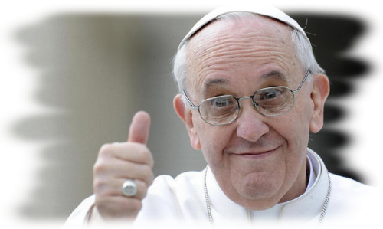
Together we can solve the problem
‘Everything in the environment thus needs to be joined to a sincere love for our fellow human beings and an unwavering commitment to resolving the problems of society.’ Paragraph 92
The earth’s resources are for all
Whether believers or not, we are agreed today that the earth is essentially a shared inheritance, whose fruits are meant to benefit everyone. Paragraph 93
We humans and other creatures depend on each other
Creatures exist only in dependence on each other, to complete each other, in the service of each other. Paragraph 86
The Church has two duties to care for nature and protect humans from themselves
The work of the Church seeks not only to remind everyone of the duty to care for nature, but at the same time “she must above all protect mankind from self-destruction.” Paragraph 79
The well-being of all is dependent on each one of us living a balanced lifestyle.
Inner peace is closely related to care for ecology and for the common good… because it is reflected in a balanced lifestyle together with a capacity for wonder which takes us to a deeper understanding of life. Paragraph 225

‘May our struggles and our concern for this planet never take away the joy of our hope.’ Paragraph 244

